WHALE SHARK & OCEANIC RESEARCH CENTER
SCHOLARSHIP APPLICATION FORM

- Personal details:

Name (as it appears on your birth certificate):
Age:
Date of birth:
Phone Number:
Nationality (country where your passport was issued):
Languages:
Current address:
Best email address to reach you at:

- What is your motivation to participate in the internship program?

- Please list any academic background and relevant experience you have.

- Please list any practical experience and relevant courses you have/have taken.

- Diving qualifications: If available, not necessary.

Max. level diving certification:
Date of first certification:
Date of last dive:
Total number of dives:
Specializations:
Do you have a current Emergency First Responder (CPR and First Aid) certification?
Do you have your own dive gear?

- What do you think about the current state of conservation management in Honduras? List at least one strength and one weakness.

- What have you personally done to aid in conservation efforts?

- What aspect of the marine environment attracts you?

- Where did you hear about our scholarship program?

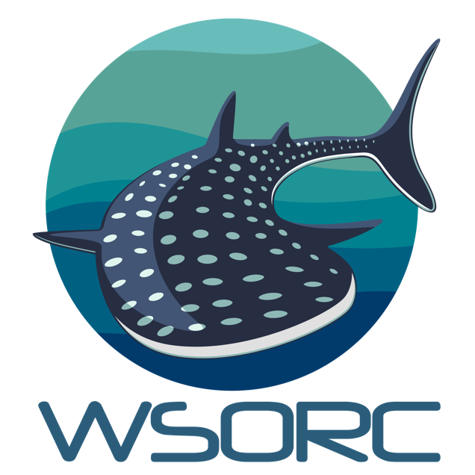
PLEASE RETURN YOUR COMPLETED APPLICATION TO info@wsorc.org.
Our team will review your application and get back to you shortly!

