WHALE SHARK & OCEANIC RESEARCH CENTER
APPLICATION FORM

- Personal details:

Name (as it appears on your passport):
Age:
Date of birth:
Nationality (country where your passport was issued):
Languages:
Current address:

Best email address to reach you at:

- Which program are you applying for? (Please select one)
Marine Conservation Internship (1 month)
Dive Master & Marine Conservation Internship (2 months)
Research Assistant (2 months if already Divemaster certified, if not 3 months)
Marine Conservation and PADI Instructor Internship (2 months)
Research Assistant and PADI Instructor Internship (3 months)

- What is your motivation to participate in the internship program you chose?

Briefly explain your motivations for applying.

- Please list any academic background and relevant experience you have.

Please list your academic background and any relevant experience you have including previous internships, volunteer excursions or research projects.

- Please list any practical experience and relevant courses you have/have taken.

Please list any qualifications you have that are relevant to this program such as first aid, boat licenses, GIS training, etc…

- Diving qualifications:

Max. level diving certification:
Date of first certification:
Date of last dive:
Total number of dives:
Specializations:
Do you have a current Emergency First Responder (CPR and First Aid) certification? If so, will it still be current upon arrival for your preferred start date?

Do you have your own dive gear?

Please note that it is our policy for all scuba certified interns to complete a 2-hour ‘scuba tune-up’ with an instructor upon arrival, priced at 30 USD. Please ensure that you arrive at least 24-hours before your internship start date to complete your refresher course. This is our policy due to the nature of our research dives which require divers to maintain excellent buoyancy, as well as to make interns feel more comfortable in the water.

- Preferred program dates: Please remember that our programs begin on the first Monday of each month, without exception. Programs last a minimum of 4-weeks for Marine Conservation Internships, or 2-3 months for Dive Master + Marine Conservation interns and Research Assistants.

Start date:
Year:

For how long?

- Where did you hear about our internship program?
Let us know how you found out about us!

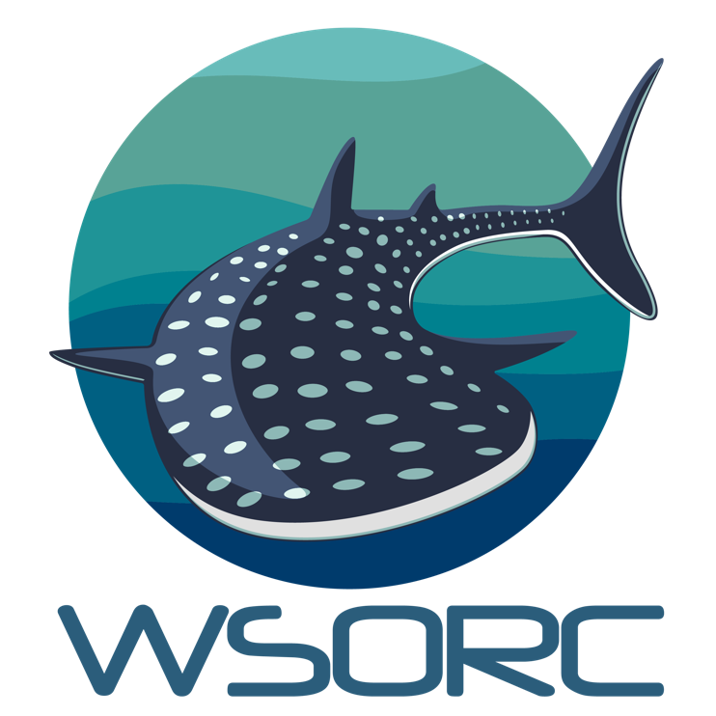
PLEASE RETURN YOUR COMPLETED APPLICATION TO info@wsorc.org.
Our team will review your application and get back to you shortly!

